**Difference between HTTP 1.1 vs HTTP2**

HTTP stands for hypertext transfer protocol, and it is the basis for almost all web applications. More specifically, HTTP is the method computers and servers use to request and send information. For instance, when someone navigates to cloudflare.com on their laptop, their web browser sends an HTTP request to the Cloudflare servers for the content that appears on the page. Then, Cloudflare servers send HTTP responses with the text, images, and formatting that the browser displays to the user.

The first usable version of HTTP was created in 1997. Because it went through several stages of development, this first version of HTTP was called HTTP/1.1. This version is still in use on the web. In 2015, a new version of HTTP called [HTTP/2](https://www.cloudflare.com/website-optimization/http2/what-is-http2/) was created.

HTTP/2 solves several problems that the creators of HTTP/1.1 did not anticipate. In particular, HTTP/2 is much faster and more efficient than HTTP/1.1. One of the ways in which HTTP/2 is faster is in how it prioritizes content during the loading process.

**HTTP/1.1**

Developed by Timothy Berners-Lee in 1989 as a communication standard for the World Wide Web, HTTP is a top-level application protocol that exchanges information between a client computer and a local or remote web server. In this process, a client sends a text-based request to a server by calling a method like GET or POST. In response, the server sends a resource like an HTML page back to the client.

For example, let’s say you are visiting a website at the domain www.example.com. When you navigate to this URL, the web browser on your computer sends an HTTP request in the form of a text-based message, similar to the one shown here:’

GET /index.html HTTP/1.1

Host: [www.example.com](http://www.example.com)

This request uses the GET method, which asks for data from the host server listed after Host:. In response to this request, the example.com web server returns an HTML page to the requesting client, in addition to any images, stylesheets, or other resources called for in the HTML. Note that not all of the resources are returned to the client in the first call for data. The requests and responses will go back and forth between the server and client until the web browser has received all the resources necessary to render the contents of the HTML page on your screen.

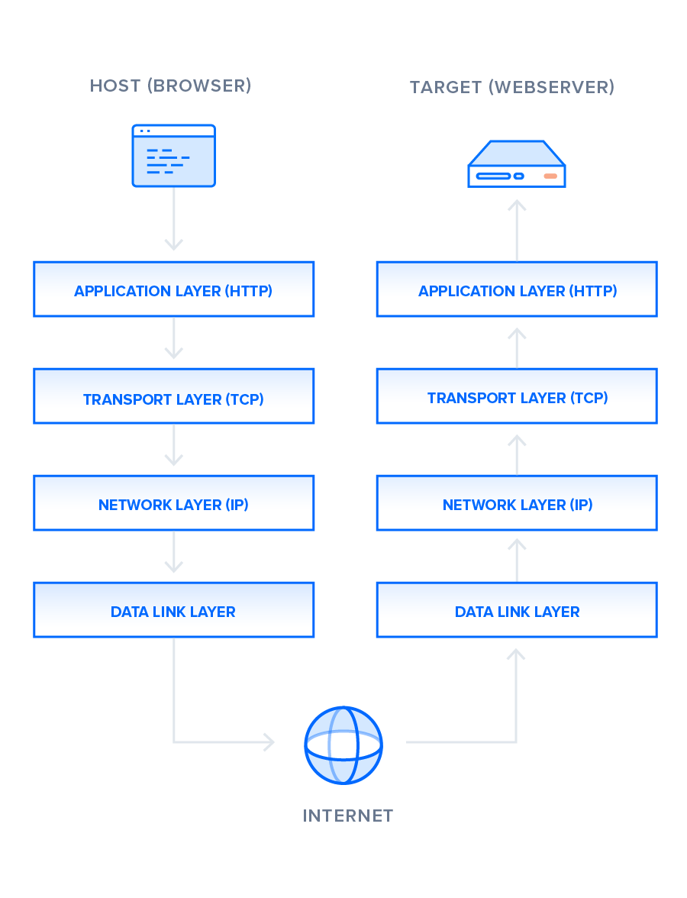

**HTTP/2**

HTTP/2 began as the SPDY protocol, developed primarily at Google with the intention of reducing web page load latency by using techniques such as compression, multiplexing, and prioritization. This protocol served as a template for HTTP/2 when the Hypertext Transfer Protocol working group httpbis of the [IETF (Internet Engineering Task Force)](https://www.ietf.org/) put the standard together, culminating in the publication of HTTP/2 in May 2015. From the beginning, many browsers supported this standardization effort, including Chrome, Opera, Internet Explorer, and Safari. Due in part to this browser support, there has been a significant adoption rate of the protocol since 2015, with especially high rates among new sites.

From a technical point of view, one of the most significant features that distinguishes HTTP/1.1 and HTTP/2 is the binary framing layer, which can be thought of as a part of the application layer in the internet protocol stack. As opposed to HTTP/1.1, which keeps all requests and responses in plain text format, HTTP/2 uses the binary framing layer to encapsulate all messages in binary format, while still maintaining HTTP semantics, such as verbs, methods, and headers. An application level API would still create messages in the conventional HTTP formats, but the underlying layer would then convert these messages into binary. This ensures that web applications created before HTTP/2 can continue functioning as normal when interacting with the new protocol.

The conversion of messages into binary allows HTTP/2 to try new approaches to data delivery not available in HTTP/1.1, a contrast that is at the root of the practical differences between the two protocols. The next section will take a look at the delivery model of HTTP/1.1, followed by what new models are made possible by HTTP/2.

**HTTP/2 — Advantages of the Binary Framing Layer**

In HTTP/2, the binary framing layer encodes requests/responses and cuts them up into smaller packets of information, greatly increasing the flexibility of data transfer.

Let’s take a closer look at how this works. As opposed to HTTP/1.1, which must make use of multiple TCP connections to lessen the effect of HOL blocking, HTTP/2 establishes a single connection object between the two machines. Within this connection there are multiple *streams* of data. Each stream consists of multiple messages in the familiar request/response format. Finally, each of these messages split into smaller units called *frames*:

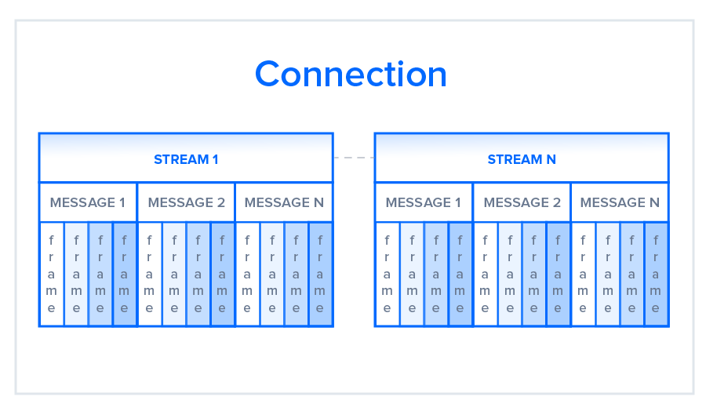

What are the other differences between HTTP/2 and HTTP/1.1 that impact performance?

**Multiplexing:** HTTP/1.1 loads resources one after the other, so if one resource cannot be loaded, it blocks all the other resources behind it. In contrast, HTTP/2 is able to use a single [TCP](https://www.cloudflare.com/learning/ddos/glossary/tcp-ip/) connection to send multiple streams of data at once so that no one resource blocks any other resource. HTTP/2 does this by splitting data into binary-code messages and numbering these messages so that the client knows which stream each binary message belongs to.

**Server push:** Typically, a server only serves content to a client device if the client asks for it. However, this approach is not always practical for modern webpages, which often involve several dozen separate resources that the client must request. HTTP/2 solves this problem by allowing a server to "push" content to a client before the client asks for it. The server also sends a message letting the client know what pushed content to expect – like if Bob had sent Alice a Table of Contents of his novel before sending the whole thing.

**Header compression:** Small files load more quickly than large ones. To speed up web performance, both HTTP/1.1 and HTTP/2 compress HTTP messages to make them smaller. However, HTTP/2 uses a more advanced compression method called HPACK that eliminates redundant information in HTTP header packets. This eliminates a few bytes from every HTTP packet. Given the volume of HTTP packets involved in loading even a single webpage, those bytes add up quickly, resulting in faster loading.

**Conclusion**

As you can see from this point-by-point analysis, HTTP/2 differs from HTTP/1.1 in many ways, with some features providing greater levels of control that can be used to better optimize web application performance and other features simply improving upon the previous protocol. Now that you have gained a high-level perspective on the variations between the two protocols, you can consider how such factors as multiplexing, stream prioritization, flow control, server push, and compression in HTTP/2 will affect the changing landscape of web development.

If you would like to see a performance comparison between HTTP/1.1 and HTTP/2, check out this [Google demo](https://http2.golang.org/gophertiles) that compares the protocols for different latencies. Note that when you run the test on your computer, page load times may vary depending on several factors such as bandwidth, client and server resources available at the time of testing, and so on. If you’d like to study the results of more exhaustive testing, take a look at the article [HTTP/2 – A Real-World Performance Test and Analysis](https://css-tricks.com/http2-real-world-performance-test-analysis/). Finally, if you would like to explore how to build a modern web application, you could follow our [How To Build a Modern Web Application to Manage Customer Information with Django and React on Ubuntu 18.04](https://www.digitalocean.com/community/tutorials/how-to-build-a-modern-web-application-to-manage-customer-information-with-django-and-react-on-ubuntu-18-04) tutorial, or set up your own HTTP/2 server with our [How To Set Up Nginx with HTTP/2 Support on Ubuntu 20.04](https://www.digitalocean.com/community/tutorials/how-to-set-up-nginx-with-http-2-support-on-ubuntu-20-04) tutorial.